Ex. No.:4 | CI Pipeline Lab: Plain Python App → GitHub Actions → Docker Hub
04-09-2025

Aim
You will create a tiny plain Python application and set up a GitHub Actions workflow that:
1) Runs tests with pytest
2) Builds a Docker image
3) Pushes the image to Docker Hub
4) (Optional) Publishes a release tag like v1.0.0

Description
This project demonstrates a simple Continuous Integration (CI) and Continuous Deployment (CD) workflow for a Python application using GitHub Actions and Docker. The workflow automates testing, building, and publishing Docker images to Docker Hub.
Key Concepts & Tools:

GitHub Actions: GitHub’s built-in automation tool that allows you to create workflows triggered by events such as code pushes, pull requests, or tags. In this lab, GitHub Actions is used to:

Run automated tests using pytest.

Build a Docker image of the Python application.

Push the image to Docker Hub.

Optionally, publish a versioned release tag (e.g., v1.0.0).

Python & Pytest: Python is the programming language used for the application. Pytest is a testing framework for Python that allows writing simple yet powerful unit tests. In this lab, we test the add function to ensure correct results.

Docker: Docker is a platform for creating, deploying, and running applications in lightweight, portable containers. Containers package the application with all its dependencies, ensuring consistent behavior across different environments. The Dockerfile defines how to build the image for the Python application.

Docker Hub: A cloud-based registry service where Docker images are stored and shared. After building the Docker image, it is pushed to Docker Hub for versioned storage and distribution.

Git & GitHub: Git is a version control system used to track code changes. GitHub is a cloud service hosting Git repositories. Code pushed to GitHub can trigger GitHub Actions workflows.

CI/CD Workflow Steps in this Lab:

Checkout: Pulls the latest code from the repository.

Set up Python: Installs Python 3.11 and required dependencies.

Run tests: Executes pytest to verify code correctness.

Docker Build & Push: Builds a Docker image and pushes it to Docker Hub with proper tags.

Optional Release Tagging: Tags the Docker image with a version like v1.0.0 for release management.

GitHub Secrets: Securely stores sensitive information (like Docker Hub credentials) required for workflows without exposing them in the code.

Prerequisites

- GitHub account
- Docker Hub account
- Git installed locally
- Python 3.11+
- Docker Desktop (optional for local testing)

Procedure

STEP 1 — Create a new project folder

mkdir python-ci-docker-lab

cd python-ci-docker-lab

STEP 2 — Create application files

app.py

def add(a, b):

return a + b

if __name__ == "__main__":

print("Hello from Python CI Lab!")

print("2 + 3 =", add(2, 3))

tests/test_app.py

from app import add

def test_add():

assert add(2, 3) == 5

assert add(-1, 1) == 0

requirements.txt

pytest==8.3.2

Dockerfile

FROM python:3.11-slim

WORKDIR /app

COPY requirements.txt .

RUN pip install --no-cache-dir -r requirements.txt

COPY . .

CMD ["python", "app.py"]

.gitignore

__pycache__/

.venv/

.pytest_cache/

.DS_Store

*.pyc

STEP 3 — Add GitHub Actions workflow

mkdir -p .github/workflows

.github/workflows/ci-dockerhub.yml

name: ci-dockerhub

on:

push:

branches: [ "main" ]

tags: [ "*" ]

pull_request:

branches: [ "main" ]

jobs:

build-test-push:

runs-on: ubuntu-latest

steps:

- name: Checkout

uses: actions/checkout@v4

- name: Set up Python

uses: actions/setup-python@v5

with:

python-version: '3.11'

- name: Install deps

run: |

python -m pip install --upgrade pip

pip install -r requirements.txt

- name: Run tests

run: pytest -q

- name: Docker meta

id: meta

uses: docker/metadata-action@v5

with:

images: ${{ secrets.DOCKERHUB_USERNAME }}/python-ci-lab

tags: |

type=raw,value=latest,enable={{is_default_branch}}

type=sha,prefix=sha-,format=short

type=ref,event=tag

- name: Set up QEMU

uses: docker/setup-qemu-action@v3

- name: Set up Docker Buildx

uses: docker/setup-buildx-action@v3

- name: Login to Docker Hub

uses: docker/login-action@v3

with:

username: ${{ secrets.DOCKERHUB_USERNAME }}

password: ${{ secrets.DOCKERHUB_TOKEN }}

- name: Build and push

uses: docker/build-push-action@v6

with:

context: .

push: true

tags: ${{ steps.meta.outputs.tags }}

labels: ${{ steps.meta.outputs.labels }}

platforms: linux/amd64

STEP 4 — Test locally (optional)

--------------------------------

python app.py

pytest -q

docker build -t yourname/python-ci-lab:local .

docker run --rm yourname/python-ci-lab:local

STEP 5 — Initialize Git & push to GitHub

git init

git add .

git commit -m "init lab"

git branch -M main

git remote add origin https://github.com/<your-username>/python-ci-docker-lab.git

git push -u origin main

STEP 6 — Add GitHub Secrets

---------------------------

- DOCKERHUB_USERNAME (your Docker Hub username)

- DOCKERHUB_TOKEN (Docker Hub access token)

STEP 7 — Watch CI run

Go to GitHub → Actions tab → select workflow run → view logs.

STEP 8 — Verify image on Docker Hub

docker.io/<DOCKERHUB_USERNAME>/python-ci-lab

STEP 9 — Release with a tag (optional)

git tag v1.0.0

git push origin v1.0.0

Output

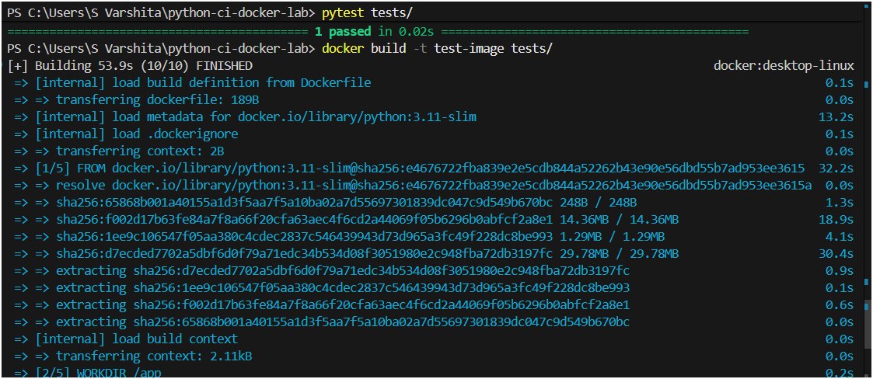

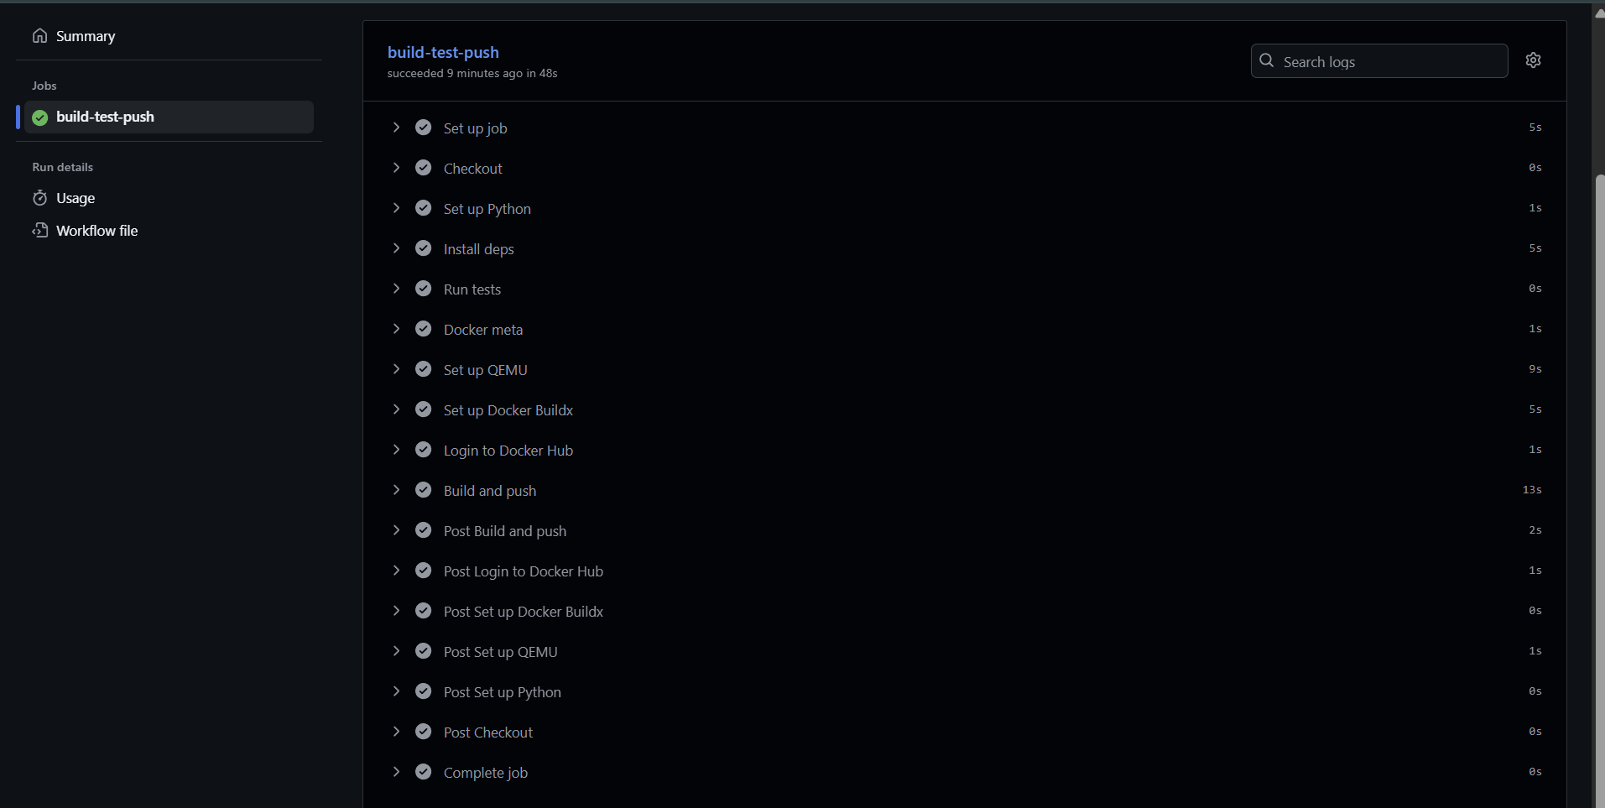

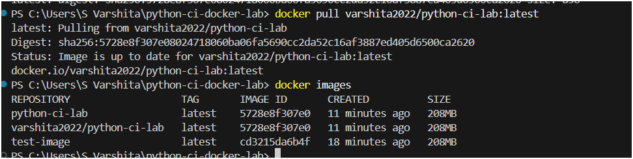

Result
This lab sets up a complete CI/CD pipeline using GitHub Actions to test a Python app with pytest, build a Docker image, push it to Docker Hub, and optionally tag a release.

